Work Breakdown Structure (WBS)

Designing an Electronic Performance Support System (EPSS)

for

WidgetMart
2345 London Avenue
London, NJ 00001

March 24, 2013

Table of Contents

Work Breakdown Structure Outline | pp. 3 - 4
Work Breakdown Structure Graphical Representation | p. 5
Work Breakdown Structure Dictionary | pp. 6 - 11
Responsibility Assignment Matrix | p. 12 - 13

Work Breakdown Structure Outline

- WidgetMart EPSS
  - Initiation
    - Evaluation & Recommendations
    - Develop SOW
    - Project Sponsor Reviews SOW
    - Adjustment to SOW
    - SOW Signed/Approved: milestone
  - Project Planning
    - Create Scope Statement
    - Determine Project Team
    - Project Team Kickoff Meeting
    - Develop Project Plan
    - Submit Project Plan
    - Project Plan Signed/Approved: milestone
  - Implementation/Execution
    - Contractor Procurement
    - Project Kickoff Meeting
    - User Requirements
      - Document User Requirements
      - Submit Requirement for review
      - Requirements Sign-off: milestone
    - Data Clean-Up
      - Identify & Discard Obsolete data - milestone
      - Identify Data for conversion: milestone
      - Categorize Data Conversion: milestone
    - Design EPSS
      - Phase 1A
      - Phase 2A
      - Phase 3A
      - Phase 4A
      - Phase 5A: milestone
    - Install EPSS
      - Phase 1B
      - Phase 2B
      - Phase 3B
      - Phase 4B
      - Phase 5B: milestone
    - Test EPSS
      - Phase 1C
      - Phase 2C
      - Phase 3C
      - Phase 4C
      - Phase 5C: milestone
    - Install Live EPSS
      - Phase 1D
      - Phase 2D
      - Phase 3D
      - Phase 4D
      - Phase 5D: milestone
    - User Training
      - Phase 1E
      - Phase 2E
      - Phase 3E
      - Phase 4E
      - Phase 5E: milestone
    - Go Live: milestone
      - Phase 1F
      - Phase 2F
      - Phase 3F
      - Phase 4F
      - Phase 5F
  - Project Monitoring/Controlling
    - Conduct Project Status Meetings
    - Manage Schedule
    - Manage Quality
    - Manage Cost
    - Manage Communication
    - Manage Performance
    - Manage Stakeholder
    - Manage Scope
    - Update Project Plan as needed
  - Project Closeout
    - Audit Procurement
    - Conduct Lessons Learned
    - Update Files/Records
    - Gain Formal Acceptance: milestone
    - Archive Files/Documents
    - End Project: milestone

Work Breakdown Structure Graphical Representation

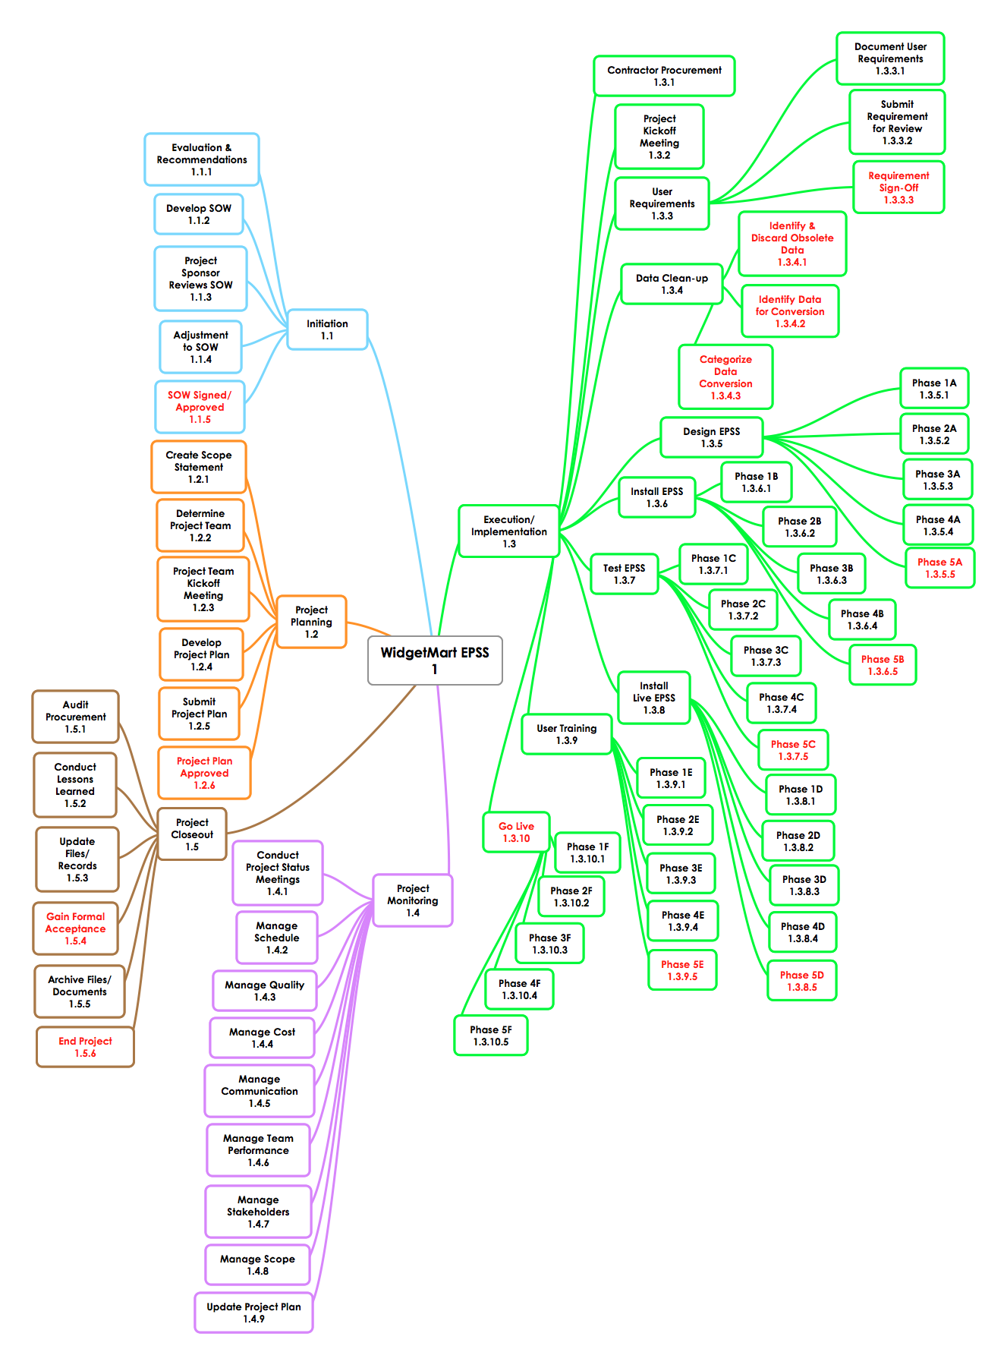
Work Breakdown Structure Dictionary

Level | WBS Code | Element Name | Definition
1 | 1 | WidgetMart EPSS | All work to develop WidgetMart Electronic Performance Support System (EPSS).
2 | 1.1 | Initiation | The work to initiate/start the project.
3 | 1.1.1 | Evaluation & Recommendations | Working group to evaluate the need and recommend solution.
3 | 1.1.2 | Develop SOW | Project manager to develop the Statement of Work (SOW).
3 | 1.1.3 | Project Sponsor Reviews SOW | Project sponsor reviews the Statement of Work and identify any revisions.
3 | 1.1.4 | Adjustment to SOW | Project manager makes revisions to the Statement of Work (SOW) if applicable.
3 | 1.1.5 | SOW Signed/Approved | Project sponsor signs and approves the Statement of Work (SOW).
2 | 1.2 | Project Planning | The work of the project in the planning process.
3 | 1.2.1 | Create Scope Statement | The project management creates the scope statement.
3 | 1.2.2 | Determine Project Team | The project management determines the project team (in-house) and contractors, and requests the resources.
3 | 1.2.3 | Project Team Kickoff Meeting | The planning process is officially started with a project team kickoff meeting which includes the Project Manager, Project Team, and appropriate project stakeholders.
3 | 1.2.4 | Develop Project Plan | The project manager, along with the project team develops the project plan.
3 | 1.2.5 | Submit Project Plan | The project manager submits the project plan for review and approval.

Level | WBS Code | Element Name | Definition
3 | 1.2.6 | Milestone: Project Plan Approved | The project plan is approved. The project manager has the permission to execute/implement the project according to the project plan.
2 | 1.3 | Execution/Implementation | The work involved to implement/execute the project.
3 | 1.3.1 | Contractor Procurement | The project manager hires contractors for the project.
3 | 1.3.2 | Project Kickoff Meeting | The project manager conducts a project kickoff meeting with the project team, project stakeholders, and sponsor.
3 | 1.3.3 | User Requirements | The work for gathering and preparing the user requirements for designing the EPSS.
4 | 1.3.3.1 | Document User Requirements | The project team documents the user requirements for designing the EPSS.
4 | 1.3.3.2 | Submit Requirement for Review | The project team submits the user requirement for review by the users.
4 | 1.3.3.3 | Milestone: Requirement Sign-Off | Users sign off on the requirements.
3 | 1.3.4 | Data Clean-Up | The work for sorting through the existing data.
4 | 1.3.4.1 | Identify & Discard Obsolete Data | The project team identifies obsolete data, and discards the data.
4 | 1.3.4.2 | Identify Data for Conversion | The project team identifies the data that will be converted to the new EPSS.
 | 1.3.4.3 | Categorize Data Conversion | The project team categorizes the data into four functional areas:  Applications with embedded knowledge  A reference function  A job aid function  A computer-based instruction function
3 | 1.3.5 | Design EPSS | All the work to design the ESS.

Level | WBS Code | Element Name | Definition
4 | 1.3.5.1 | Phase 1A | The project team designs phase 1: Applications with embedded knowledge.
4 | 1.3.5.2 | Phase 2A | The project team designs phase 2: A reference function.
4 | 1.3.5.3 | Phase 3A | The project team designs phase 3: A job aid function.
4 | 1.3.5.4 | Phase 4A | The team designs phase 4: A computer-based instruction function.
4 | 1.3.5.5 | Phase 5A (milestone) | The project team designs phase 5: Integration of phase 1 through 4.
3 | 1.3.6 | Install EPSS | All the work required to install the (newly designed) EPSS.
4 | 1.3.6.1 | Phase 1B | The project team installs phase 1 functionality: Application with embedded knowledge.
4 | 1.3.6.2 | Phase 2B | The project team installs phase 2 functionality: A reference function.
4 | 1.3.6.3 | Phase 3B | The project team installs phase 3 functionality: A job aid function.
4 | 1.3.6.4 | Phase 4B | The project team installs phase 4 functionality: A computer-based instruction function.
4 | 1.3.6.5 | Phase 5B (milestone) | The project team installs phase 5 functionality: Integration of phase 1 through 4.
3 | 1.3.7 | Test EPSS | All the work required to test the newly installed EPSS.
4 | 1.3.7.1 | Phase 1C | The project team develops test cases and runs the test for phase 1 functionality: Application with embedded knowledge.
4 | 1.3.7.2 | Phase 2C | The project team develops test cases and runs the test for phase 2 functionality: A reference function.
4 | 1.3.7.3 | Phase 3C | The project team develops test cases and runs the test for phase 3 functionality: A job aid function.
Level | WBS Code | Element Name | Definition
4 | 1.3.7.5 | Phase 5C (milestone) | The project team develops test cases and runs the test for phase 5 functionality: Integration of phase 1 through 4.
3 | 1.3.8 | Install Live EPSS | All the work required to install the (newly designed & tested) live EPSS.
4 | 1.3.8.1 | Phase 1D | The project team installs the live phase 1 functionality: Application with embedded knowledge.
4 | 1.3.8.2 | Phase 2D | The project team installs the live phase 2 functionality: A reference function.
4 | 1.3.8.3 | Phase 3D | The project team installs the live phase 3 functionality: A job aid function.
4 | 1.3.8.4 | Phase 4D | The project team installs the live phase 4 functionality: A computer-based instruction function.
4 | 1.3.8.5 | Phase 5D (milestone) | The project team installs the live phase 5 functionality: Integration of phase 1 through 4.
3 | 1.3.9 | User Training | All the work required to train the users of the EPSS.
4 | 1.3.9.1 | Phase 1E | The project team develops training materials and trains users on phase 1 functionality of the EPSS: Application with embedded knowledge.
4 | 1.3.9.2 | Phase 2E | The project team develops training materials and trains users on phase 2 functionality of the EPSS: A reference function.
4 | 1.3.93 | Phase 3E | The project team develops training materials and trains users on phase 3 functionality of the EPSS: A job aid function.
4 | 1.3.9.4 | Phase 4E | The project team develops training materials and train users on phase 4 functionality of the EPSS: A computer-based instruction function.

Level | WBS Code | Element Name | Definition
4 | 1.3.9.5 | Phase 5E | The project team develops training materials and trains users on phase 5 functionality of the EPSS: the integration of all the functionalities.
3 | 1.3.10 | Go Live (milestone) | All the work required to put the EPSS in production – available to users.
4 | 1.3.10.1 | Phase 1F | The actual system goes live for Phase 1: Application with embedded knowledge.
4 | 1.3.10.2 | Phase 2F | The actual system goes live for Phase 2: a reference function.
4 | 1.3.10.3 | Phase 3F | The actual system goes live for Phase 3: A job aid function.
4 | 1.3.10.4 | Phase 4F | The actual system goes live for Phase 4: A computer-based instruction function.
4 | 1.3.10.5 | Phase 5F | The actual system goes live for Phase 5: Integration of phases 1 through 4.
2 | 1.4 | Project Monitoring | The project management work required to ensure the project progresses as planned.
3 | 1.4.1 | Conduct Project Status Meetings | The project manager conducts regular project status meetings.
3 | 1.4.2 | Manage Schedule | The project manager ensures the project is on schedule; making adjustments as required.
3 | 1.4.3 | Manage Quality | The project manager ensures all quality processes are in place and utilized.
3 | 1.4.4 | Manage Communication | The project manager ensures effective and productive communication among team members.
3 | 1.4.5 | Manage Team Performance | The project manager ensures the team performance is aligned with the project’s requirements.
3 | 1.4.6 | Manage Stakeholders | The project manager ensures stakeholders are aware of the project status, addresses any issues.
Level | WBS Code | Element Name | Definition
3 | 1.4.7 | Update Project Plan | The project manager updates the project plan as needed.
2 | 1.5 | Project Closeout | All the work required to finalize and closeout the project.
3 | 1.5.1 | Audit Procurement | The project manager ensures contractors completed their obligations and satisfies any outstanding payment.
3 | 1.5.2 | Conduct Lessons Learned | The project manager, with the team, conducts and documents lessons learned.
3 | 1.5.3 | Update Files/Records | The project manager updates the organization’s project files/records with the information from the current project.
3 | 1.5.4 | Gain Formal Acceptance (milestone) | The project manager (and the team) hand off the project to the client and get acceptance sign off.
3 | 1.5.5 | Archive Files/Documents | The project manager archives project information.
3 | 1.5.6 | End Project (milestone) | The project manager formally releases the project team.

Designing an Electronic Performance Support System (EPSS) for WidgetMart

Responsibility Assignment Chart

Activities | Davey J. (PM) | Ellen G. | Josie B. | Tim S. | Barry O. | Project Staff A | Project Staff B | WidgetMart CEO
Evaluation & Recommendations | A | P | S | S | S
Develop SOW | P | C | C | C | C
Project Sponsors Reviews SOW | C | I | I | I | I |  |  | P
Adjustment to SOW | P | S | C | C | C
SOW Signed/Approved | I |  |  |  |  |  |  | P
Create Scope Statement | P
Determine Project Team | P | S | S | S | S
Develop Project Plan | P | S | S | S | S
Submit Project Plan | P
Project Plan Approved | I | I | I | I | I |  |  | P
Contractor Procurement | P | C | C | C | C |  |  | A
Project Kickoff Meeting | P | I | I | I | I | I | I | I
User Requirements | A | P | S |  |  | S | S | A
Data Clean-Up | A |  | P | P | C | S | S
Design EPSS | A, C | P | S | S | C | S | S | P

Activities | Davey J. (PM) | Ellen G. | Josie B. | Tim S. | Barry O. | Project Staff A | Project Staff B | WidgetMart CEO
Install | A | S | S | I | I | P | P
Test | A |  | S | S |  | P | P
Install Live | A | S |  |  |  | P | P | I
User Training | P | C |  | S, C | S, C
System in production (Go Live) | A | S | I | I | I | P | P | I
Project Monitoring | P | C | C | C | C
Project Closeout | P |  |  |  |  |  |  | A

Assignment Key definition:

P – team member with Primary responsibility to the specific task.
A – team member with Approval authority.
S – team member with Secondary responsibility to the specific task.
C – team member participates as a Consultant.
I – team member needs to be Informed.

Note:

The responsibility assignment chart will be updated; additional resources, assignment changes, etc., as the project progresses. Project Staff A and B are contractors to be hired for the project.

Rationale Statement
_______________________________________________

Case # 25 – Designing an Electronic Performance Support System for WidgetMart
(Ertmer & Quinn, 2007)

The Work Breakdown Structure (WBS) for WidgetMart shows all work to be performed in designing the Electronic Performance Support System. The project is estimated to take one year to complete, and is considered a long-term project. And as suggested in (Portny, Mantel, Meredith, Shafer, Sutton, & Kramer, 2008, p. 90) I have broken down the project into five phases. I have used the top-down approach and defined up to four levels of tasks and subtasks. Further breakdown of tasks will be necessary during the scheduling process of the project.

The Work Breakdown Structure (WBS) for WidgetMart is presented in both an outline view, and a hierarchical representation (graphical view) using a mind mapping software. I chose a mind mapping software for its practicality, flexibility, visual appeal, and ease of use in accommodating the number of tasks required for the project. Additionally, I have developed a Work Breakdown Structure (WBS) Dictionary. The WBS Dictionary “describes each component in the work breakdown structure (WBS).” PMBOK Guide, 2008, p. 445). WidgetMart’s WBS Dictionary contains all the tasks depicted in the outline and the graphical view of the WBS, and the definition/explanation of each one of those tasks.

References

Ertmer, P. A. & Quinn, J. (2007). The ID CaseBook. Case Studies in Instructional Design.
Upper Saddle River, NJ: Pearson Education, Inc.

PMBOK Guide (2008). A Guide to the Project Management Body of
Knowledge (PMBOK® Guide). (p. 445). 4th ed. Newton Square, PA: Project Management Institute, Inc.

Portny, S. E., Mantel, S. J., Meredith, J. R., Shafer, S. M., Sutton, M. M., & Kramer, B.
E. (2008). (p. 90). Project Management: Planning, scheduling, and controlling projects. Hoboken, NJ: John Wiley & Sons, Inc.

