Substitute Childcare Provider

Training Manual

ALL BY MYSELF Family Childcare Center

Table of Contents

|  |  |
| --- | --- |
| Unit 1 – Getting Familiar with the Childcare Center Setting | p. 3 |
| Unit 2 – Daily Routines & Activities | pp. 3 – 7 |
| AM Schedules | p. 5 |
| PM Schedules | pp. 6 - 7 |
| Unit 3 – Safety Rules & Procedures | p. 8 |
| Unit 4 – Proper Hygiene Procedures | p. 8 - 9 |
| Unit 5 – Emergency Management | p. 9 |
| Children’s Personal Records | p. 10 |
| Appendix | pp. 11 - 15 |
| Daily Report Form | p. 11 |
| Discipline Policy | p. 12 |
| Safety Rules | p. 13 |
| Emergency Management Procedures | p. 14 |
| Emergency Evacuation Plan Diagram | p. 15 |

**Substitute Provider Training – Student Manual**

Hello and welcome to the *Substitute Provider Training* at ALL BY MYSELF family childcare center. My name is Marta Pulley and I am the owner of and the childcare provider at the center. I am also your trainer. In this training, you will come to know and be able to perform the daily operations of the center as a substitute childcare provider. This manual will guide you through the instruction as presented by the trainer—follow your trainer’s lead. After completing the training and when you start your substitute role, the manual can also serve as your job-aid.

The following topics are covered in this training. At the end of each unit, you will complete assessments relevant to the unit (quiz, demonstrating tasks).

**Unit 1 – Getting familiar with the childcare center setting**

1. Get to know the children at the center (who’s who)
2. Tour the facility and identify the space and equipment/supplies designated for childcare (Indoors)
3. Tour the facility and identify the space and equipment/supplies designated for childcare (Outdoors)

As you are touring the facility, take mental and written notes on the key points below.

**Key Points**

* Children’s names, ages, and any special characteristic, preferences, and/or special needs.
* The space, equipment, and supplies designated for childcare tasks, both indoors and outdoors.

**Unit 2 – Daily Routines/Activities**

1. Arrival Procedures
2. Settling In
3. Activities for Toddlers
4. Activities for Infants
5. Meal Preparation
6. Nap (sleep) Procedures
7. School Bus Arrival
8. Homework Help
9. Personal Time for Care Giver
10. Daily Report Recording
11. Departure Procedures

As the trainer explains the daily routines and activities, take notes on the key points below:

**Key Points**

* The routines/activities and their scheduled times
* The arrival (drop-off) and departure (pick-up) procedures
* Approaches to maintaining a positive attitude during your stay at the center
* Approaches to fostering a “feel at home” environment for the children

|  |  |  |
| --- | --- | --- |
| **Morning (AM) Schedule** | | |
| Time | Activity | What you will do |
| 8 – 9 | Arrival | Greet and help parents unload car, and take children out of car seats.  Upon entering the house, help young children put away their coats, hats, gloves, and shoes, as needed.  After parents leave, direct children to the playroom while you organize/put away their belongings. |
| 9 – 10 | Settling In | Leave out a few age appropriate toys and books for the children. This is a free time for the children to warm up to and settle in the daily routine. You can monitor to make sure everyone is playing nice. This is also a good time to read a story to the children. Pay extra attention to the infants. |
| 9:30 – 10:00 | Feeding | Feeding time for babies (bottles). Bottles, with pre-mixed formula are labeled with the child’s name. Be sure to match the baby with the right formula/bottle. |
| 10 – 12 | Morning nap  Play Time | Morning naptime for those who need it (mostly the infants under 18 months old). Change their diapers. Place the infants safely in their respective playpens/cribs. During this time, you will be with the other children in the playroom doing the planned activity for that day (painting, dress-up play, kitchen play, outdoors, etc.). The primary provider will leave instructions for the daily activity on your substitute day. If you go outside, be sure to bring the baby monitor so you can listen to the sleeping children. |
| 11 – 11:30 | Reading | Ask each child to pick his/her favorite book and read to them. |
| 11:30 – 12 | Lunch Preparation | The children bring their own lunch. You will need to heat up the lunches (if needed) and serve. This is the time the children can watch TV/video if they seem restless. Otherwise, they can continue to play while you prepare the lunches. The provider will leave instructions for what to watch. |

|  |  |  |
| --- | --- | --- |
| **Afternoon (PM) Schedule** | | |
| Time | Activity | What you will do |
| 12 – 1 | Lunch (Eating time) | Serve lunch. Be sure you read the name(s) on the lunch boxes and serve the right lunch to the right child. Monitor the meal- time process, help those who are not completely capable of feeding themselves. Make sure the food is cut up small enough to prevent chocking. Give the infant their bottles. If they have started on baby food, you will need to feed them. When everyone is finished eating/drinking, clean up the eating area, wipe/wash children’s hands, face, as needed. |
| 1 – 2 | Outdoor Play | The children must spend at least 30 minutes a day outdoors except in the following weather conditions:   * Temperature below 25 degrees * Temperature above 90 degrees * Rain, thunderstorm * Heavy snow * Strong wind   Make sure all the children are dressed appropriately for the outdoors. You will need to come prepared to spend time outdoors. |
| 2 – 5 | Nap  Unwind  Snack  School Bus  Homework | Prepare children for naps. Change diapers or assist with potty accordingly, before napping. Place children in their respective sleeping area (playpens, cots). Usually, they will all nap from around 2:30 PM to 5:00 PM. |
| 2:30- 3:30 | Time to breath | This is your time to unwind, eat lunch, have tea, read, etc. |
| 3:30 – 3:45 | Daily Report for infants | Complete the daily report forms for the infants. The report is optional for children over 2 years old. The primary provider will leave blank forms of the report for your use. |
| 3:45 – 3:50 | School Bus Arrives | The after school care children will be getting off the bus. The bus stops right in front of the driveway. Be sure to see them off the bus and come into the house safely. Upon entering the house, they take shoes off, wash up, and get ready for snack. |

|  |  |  |
| --- | --- | --- |
| **Afternoon (PM) Schedule** | | |
| Time | Activity | What you will do |
| 3:50 – 4:10 | Snack for the after school care children | Snack time and clean up after snack. You do not need to prepare the snack; the provider would have snack prepared. You will just need to serve it. |
| 4:10 – 5:15 | Homework & Reading | The after school care children will do homework, followed by independent reading. You may assist them if they need help. Check their homework after they’re done. |
| 5:00 | Nap ends | Wake up the younger children from nap. |
| 5 – 5:15 | Snacks for the younger children | Serve snacks and/or baby formula accordingly. When done, clean up (wash/wipe children’s hands, faces) |
| 5:15 – 5:30 | Departure (Pick-up) | Prepare children for pick-up. Put on hats, coats, shoes, etc. Be sure to pack their belongings in the appropriate bags/back packs/lunch bags. The older children can pack their own belongings. Just remind them not to leave their homework behind. When everyone is done, go out to the front porch (weather permitting, otherwise wait in the foyer) and wait for parents to arrive.  Help parents load the car, assist with buckling the children in car seats, wish good night. |
| 5:30 – | Freedom! | After the children leave, go back inside and make sure the facility is all in order; toys are in place, high chairs are folded and put away, eating area is cleaned. You are done! |

**Unit 3 – Safety Rules and Procedures**

1. Safety Rules and Procedures for Indoors
   1. Playtime
   2. Nap time
   3. Meal time
   4. Diaper changing
   5. “Potty” time
   6. Proper use of childcare equipment
2. Safety Rules and Procedures for Outdoors
   1. The outdoors temperature
   2. Playing in the sandbox
   3. Playing in the yard
   4. Playing with water
   5. Walking in the woods
   6. Rules about the driveway
   7. Rules about staying “together”
   8. Rules Regarding Visitors
   9. Rules Regarding the Safe Releasing of Children to Authorized Guardian/Persons
   10. Safe Multi-Tasking Procedures
       1. Defining “multi-tasking”
       2. Staying calm
       3. Applying safe multi-tasking procedures

As the trainer explains and demonstrates the safety rules and procedures, take notes on the key points below:

**Key Points**

* The safety rules and procedures pertaining to the substitute care provider (you)
* The safety rules and procedures pertaining to the facility
* The safety rules and procedures pertaining to the children
* Safe multi-tasking strategies

**Unit 4 – Proper Hygiene Procedures**

1. Hygiene for Caregiver
2. Hygiene for Children
3. Disposal of Used Diapers
4. Sanitization of Used Surfaces, Toys
5. Cleaning of Meal Preparation and Eating Area
6. General Cleanliness of The Facility

As the trainer explains and demonstrates the proper hygiene procedures, take notes on the key points below:

**Key Points**

* The importance of maintaining proper hygiene as defined in the center’s policy
* Properly sanitizing the indoors playing area, including toys, using a Multi-Surface Disinfectant
* Properly cleaning the meal preparation and eating area

**Unit 5 – Emergency Management**

1. Define “Emergency”
   1. Emotional Crisis (temper tantrums, apparent distress)
   2. Illness (flu, stomach virus, high fever, unusual lethargy)
   3. Any Life-Threatening Symptoms (fainting, seizure, chocking)
   4. Noticeable or Suspected Injury From a Fall
   5. When Parents Could Not Be Reached
   6. Danger On The Premises Other Than Fire
   7. Substitute Provider Emergency
2. Fire/Smoke Evacuation Procedures
3. Children’s Emergency Contact Information & Procedures
4. Contacting the Primary Childcare Provider
5. Administering Medication
6. Administering First Aid or CPR

As the trainer explains and demonstrates the emergency management protocols, take notes on the key points below:

**Key Points**

* What constitutes an “emergency” situation?
* The Fire Evacuation procedures
* The general “emergency” management procedures

**Children’s Personal Records**

For each child, the center keeps a folder containing the following information:

**Emergency Medical Treatment Authorization Form**

* This from indicates the child’s parents’ or guardians’ instructions and/or permission to the provider to administer medication, and authorize any hospitalization necessary in their absence or if provider is unable to contact them.

**Drop Off/Pick Up Authorization Form**

* The name and contact of the person(s) authorized to pick up or drop off the child in the absence of parents.

**Emergency Contact List**

* The name and contact of the person(s) you would contact in case of an emergency, if parents could not be reached.

**Medical History/Immunization Record**

* Important if child is ill or injured and medical professionals (paramedics or physician) need the information. This form also indicates any life-threatening conditions or allergies the child may have.

**Childcare Enrollment information**

* This form contains the child’s name, age, DOB, address, parent’s home and work contact information, and the child’s Medical Insurance Provider Identification number and the member service number.

The folders will be placed near an exit door on a visible and easily accessible spot. If you need to exit the facility for some type of emergency, bring the folders with you.

**How I Spent My Day**

**On Date:**

|  |  |  |
| --- | --- | --- |
| **Meal** | **Time** | **What I ate** |
| Breakfast |  |  |
| Morning Snack |  |  |
| Lunch |  |  |
| Afternoon Snack |  |  |
| Other |  |  |

**During the day I did the following:**

|  |  |
| --- | --- |
| **Activities** | **Description of Activities** |
| Reading |  |
| Coloring |  |
| Outdoors |  |
| Quiet Play |  |
| Music |  |
| Television |  |
| Other |  |

**I had a diaper change at:**

|  |  |
| --- | --- |
| **Time** | **Type (Wet or BM)** |
|  |  |
|  |  |
|  |  |
|  |  |
|  |  |
|  |  |
|  |  |

**I napped from (hours):**

Any other things that happened today:

|  |  |
| --- | --- |
| Health |  |
| Accidents |  |
| Visitors |  |
| Mood (energetic, anxious, quiet, sad, tired, sleepy, cranky, other) |  |

## Discipline Policy

The Discipline Policy below is in direct compliance with the State of New Jersey Department of Human Services, Manual of Standards for Child Care Centers section 10:122-6.8:A-E.

The provider’s Discipline Policy will be handled in the following manner:

1. The first time the behavior is exhibited, the child will be spoken to and given an explanation as to why his/her behavior is unacceptable and how he/she can correct it.
2. The second time the behavior is exhibited, the child will be given a verbal warning and removed from the activity to do some other activity.
3. The third time the behavior is exhibited, the child will sit in “time out”. This gives the child time to think about his/her behavior and why it is unacceptable.

If the behavior persists, the parents will be notified.

* The methods of guidance and discipline used shall be positive, consistent with the development of the child and supplied with the full knowledge, understanding and approval of the parent(s).
* There shall be no hitting, corporal punishment, abusive/foul language, ridicule or harsh, humiliating or frightening treatment.
* Discipline shall not be associated with the behavior of children in regard to rest, toilet training, or food.
* Child shall not be isolated without supervision.
* Discipline shall not be associated with the withholding of emotional responses or stimulation and shall not require the child to remain silent for long periods of time.

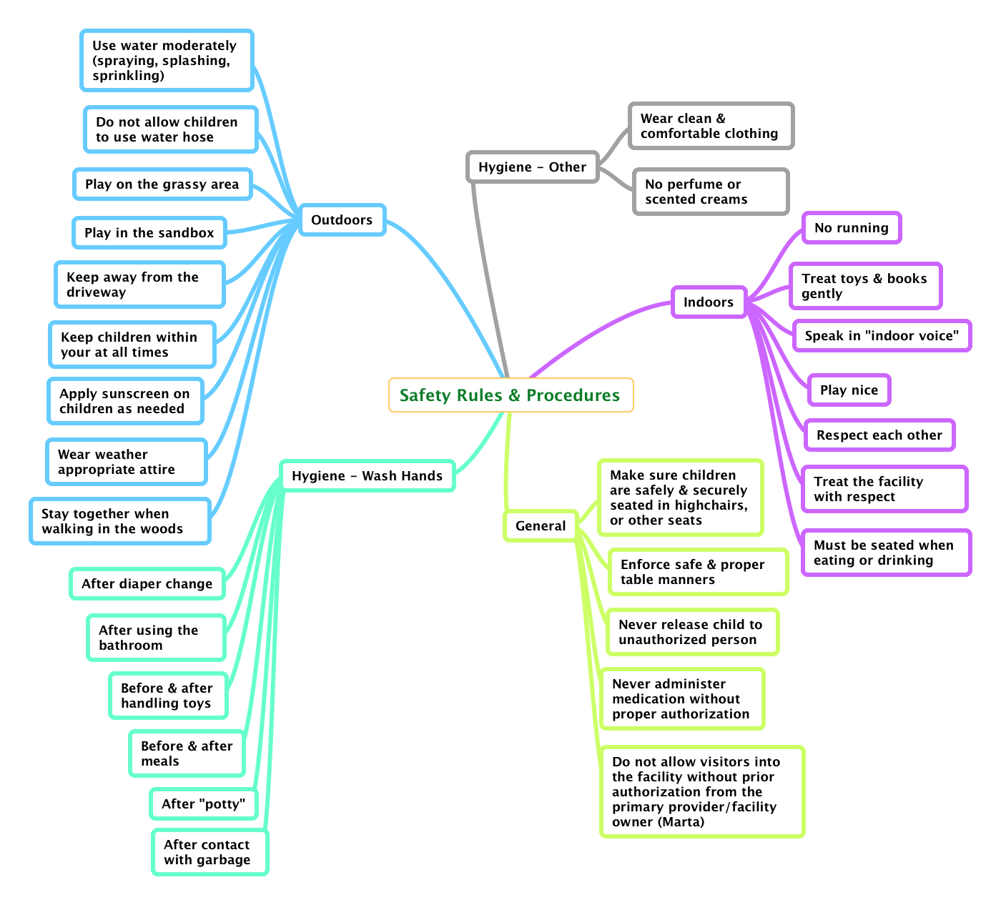**Emergency Management Procedures**

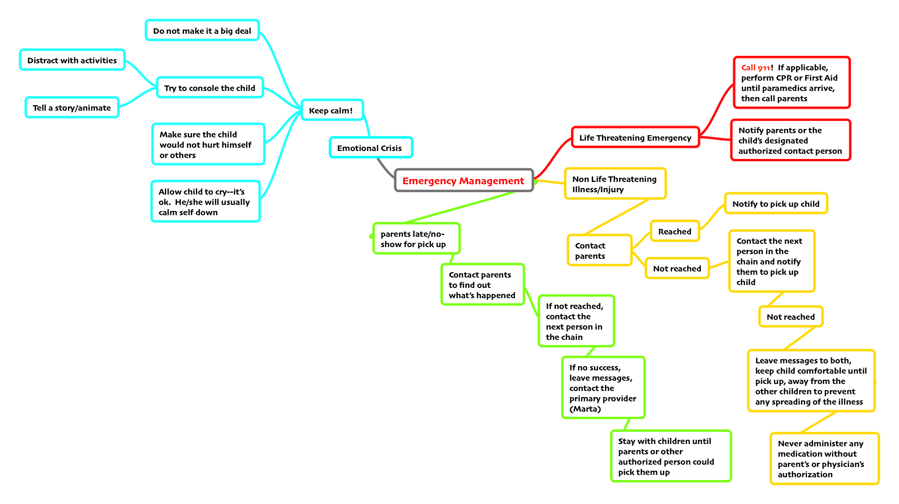

## ::Desktop:AllByMyselfFireEvacuation.jpg